Arduino based Snake Robot Controlled using Android

The snake contains twelve segments motivated by servo motors and joined with metal brackets. The servos are controlled by an Arduino Mega and powered by a 7.4-volt battery pack. The snake can be controlled by an android app using Bluetooth. The snake is also capable of autonomous movement. Such a robot can be constructed with many different types of servos and brackets. Each of the 12 segments consists of a servo motor, a C-bracket, a side bracket, a wire clip and a set of Lego wheels. Two screw holes got to be drilled into the Lego wheel axle to permit it to be connected to the C-bracket. After all, 12 segments are connected, head and tail sections need to be added in order to accommodate the Arduino and batteries. To make them a side bracket and two long C-brackets connected. The Arduino and therefore the 5AA battery holder that powers it into the tail section of the snake. The servos are powered by a separate supply, the 7.4-volt battery pack, which went into the head of the snake. On the receiver, the bottom pin is connected to the Arduino ground. The voltage pin is connected to a 5-volt pin from the Arduino.

Block Diagram:

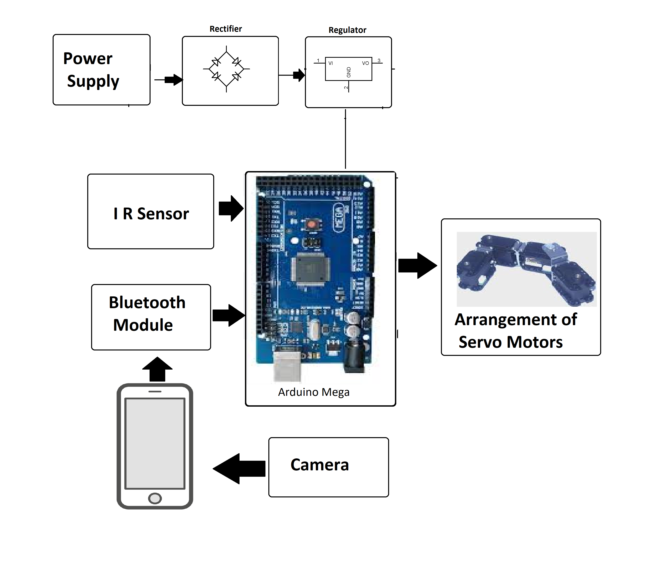

Hardware Specifications

- Arduino mega
- IR Sensor
- Servo Motors
- Bluetooth module
- Camera
- Cables and Connectors
- PCB and Breadboards
- Push Buttons
- Switch
- IC

Software Specifications

- Arduino Compiler
- Programming Language: C

